<a href=”” />

<div class=”parent”>

<div class=”child”>Chhild</div>

</div>

.parent {

text-align : centre

}

Pseudo::nth

**console.log("3"+5+7) - 312**

**function showText(){**

**var text ="Resume 1";**

**name = "Sample 1";**

**}**

**showText();**

**console.log(text); - undefined**

**console.log(name); - error**

**<section onclick="alert('section')">**

**<div onclick="alert('div')">**

**<p onclick="alert('paragraph')"> This is paragraph </p>**

**</div>**

**</section>**

**If I click on this is a paragraph: Sequence of alert -> paragraph, div, section**

**var str1 = "racecar";**

**console.log(isPalindrome(str1));**

**Function isPalindrome(str1) {**

**Let reverseStr = “”**

**For (let i = str1.length - 1; i >=0; i–) {  
 reverseStr += str1[i]**

**}**

**Return reverseStr === str1**

**}**

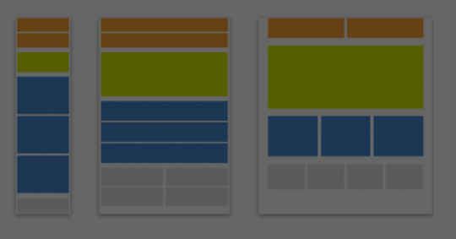

@media screen and (max-width : 600px) {

.z ,.y,.x {

Width: 100%

}

}

@media screen and (max-width : 1200px) {

.z ,.y,.x {

Width: 100%

}

}

@media screen and (max-width : 1500px) {

.z ,.y,.x {

Width: 100%

}

}

<header class=”x”>

</header>

<main class=”y”>

<section></section>

<section></section>

</main

<footer class=”z”>

</footer>